SPRING REST HANDSON
MANDATORY
OUTPUT SCREENSHOTS

- Create a Spring Web Project using Maven

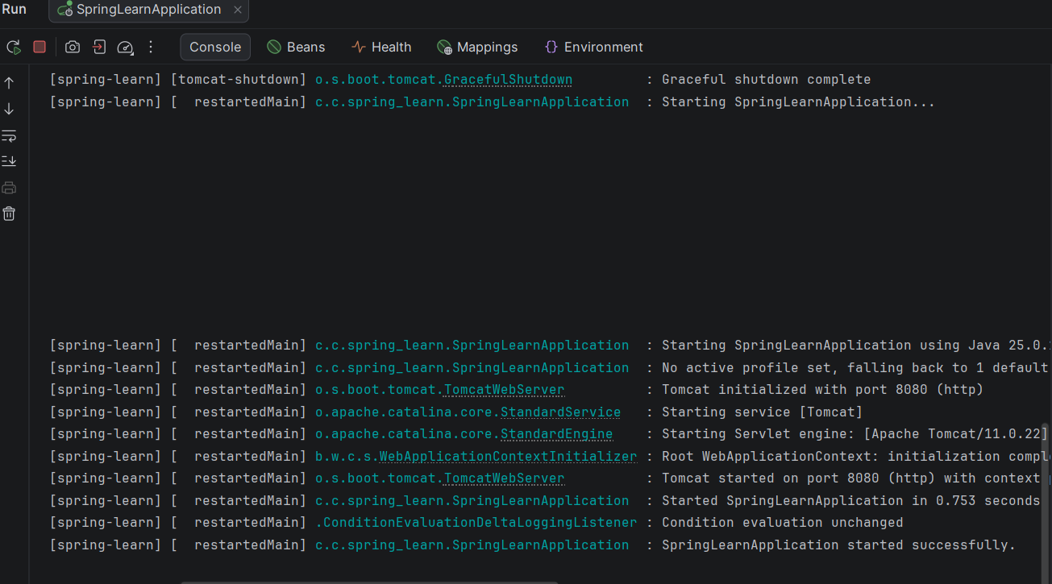

- Spring Core – Load Country from Spring Configuration XML
